**Quiz VII-D Cortland Watson**

Part I – Individual Quiz (Before Class)

Part II – Group Quiz (During Class)

1. Did you complete the reading (6 points)?

Yes

**End of Part I**

1. Were you in class on time (2 pts)?

Yes

The effects of three factors: fee level (high/low), scope of work (in-house/sub-contracted), and type of supervisory control (local/traveling supervisors) on the quality of work performed by independent marketing research agencies was assessed. Higher quality ratings are better. The file (see attached data file - in Quiz VII- D) contains the data. In this exercise, you will assess the effects of these three factors on the quality.

Do the following.

(a) Do a data decomposition and degrees of freedom of this analysis (3 points)

(b) Complete an ANOVA table showing the sum of squares, degrees of freedom, F, and P-value for each of the main effects and all interactions using R. Make Conclusions based off of the results (3 points)

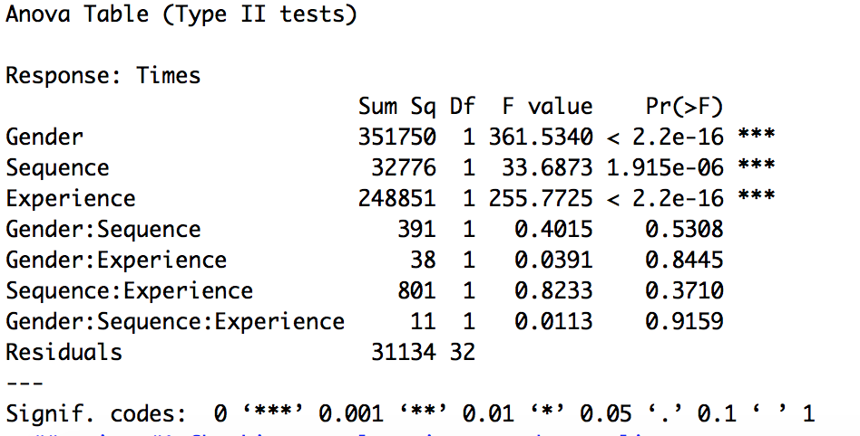

The three main factors are significant, but none of the interactions are.

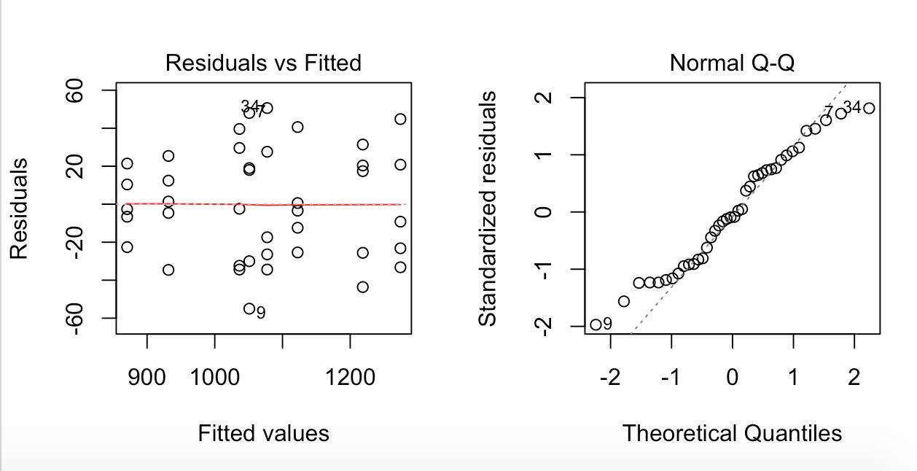

We have equal variance, but the normality is questionable, but we will proceed.